IoT Lab 3

**Name:** Cao Xinyang

**HDU Number:** 20321308

**My Photo:**



**Job issue for the work:**

Use the road network built previously during the Work1 and developed at the Work 2.

Add the traffic lights to let manage passing the intersections.

Use the tutorial to make the user interface for varying the traffic light phases.

Perform the experiment to find the traffic lights phases maximizing the road throughput:

a) change the phases durability;

b) adding the yellow phases and their durabilities;

c) adding additional sections onto the traffic lights if necessary

**Model with traffic lights:**

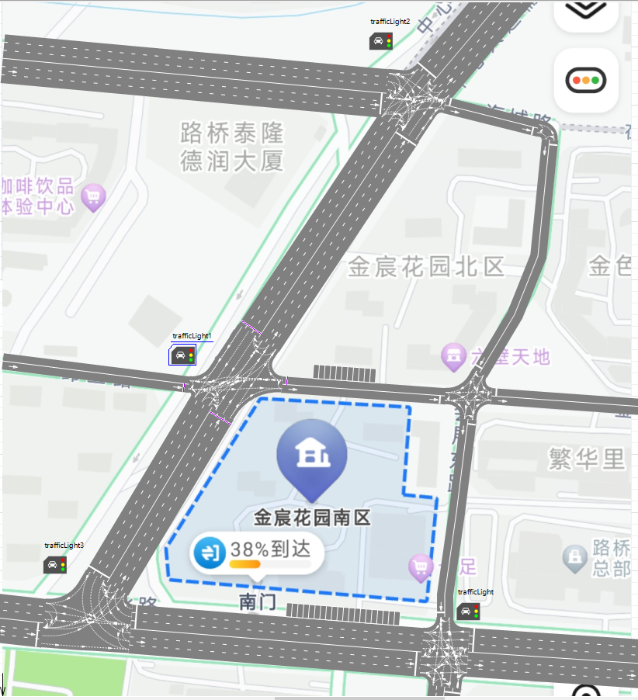

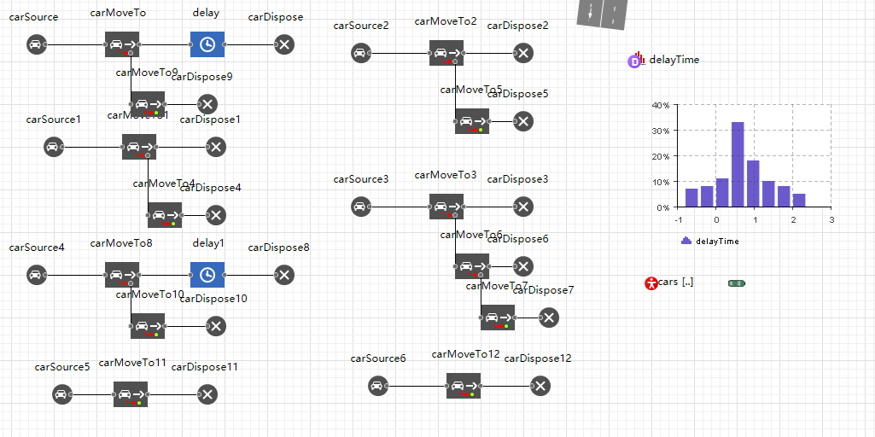

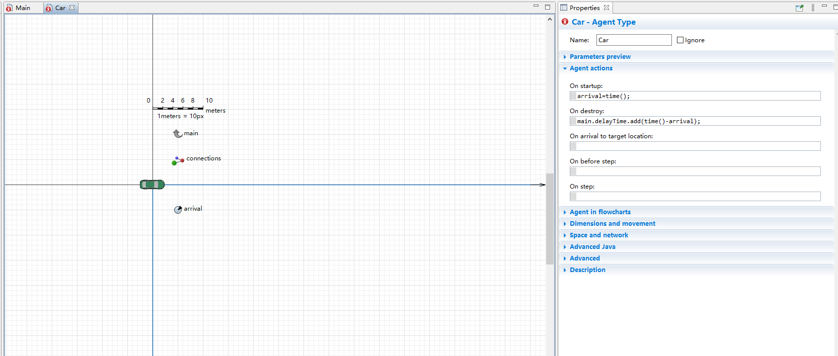

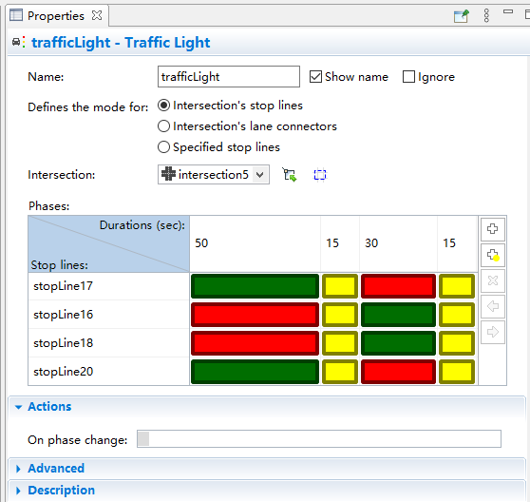 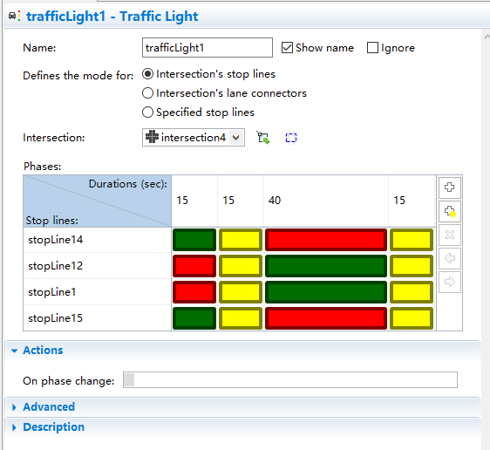

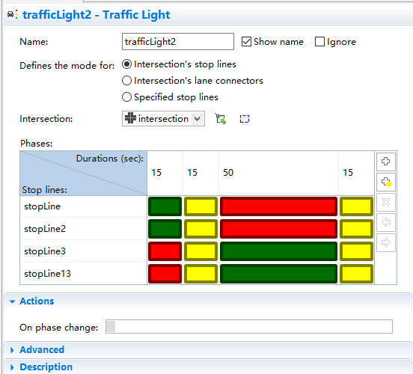 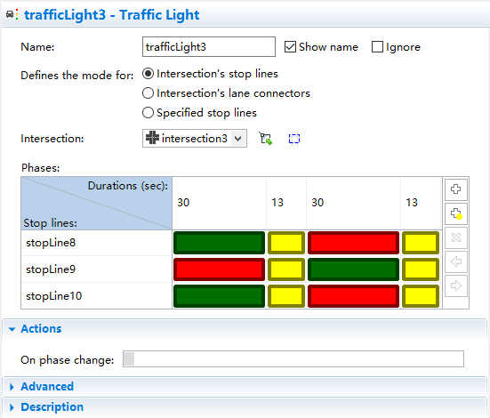

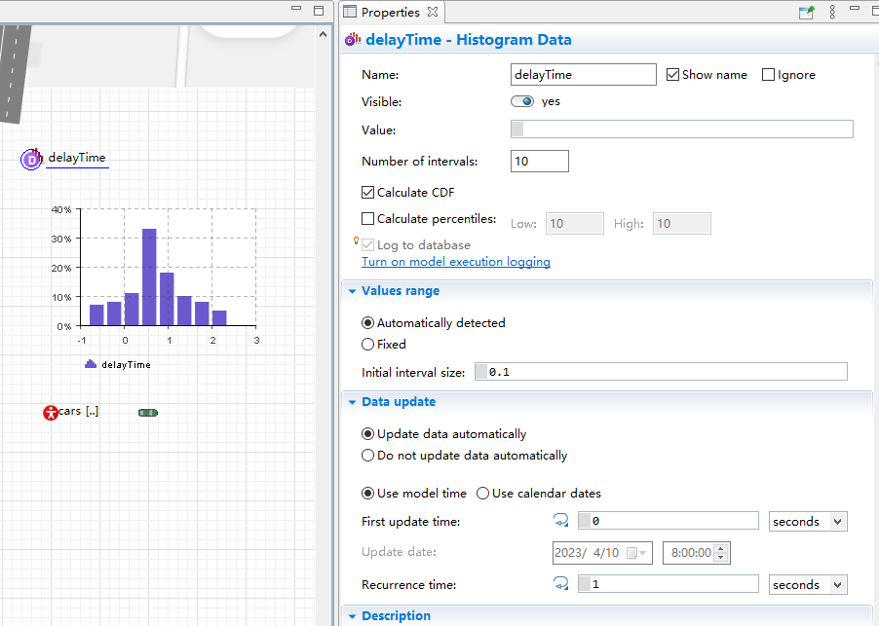 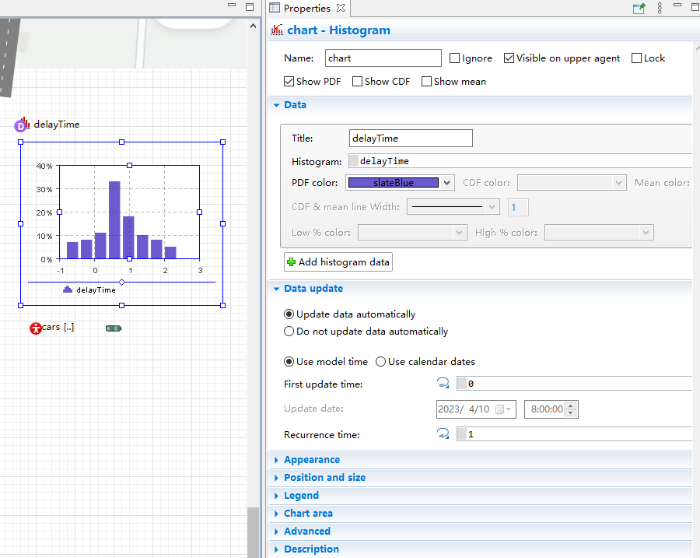

**Run time:**

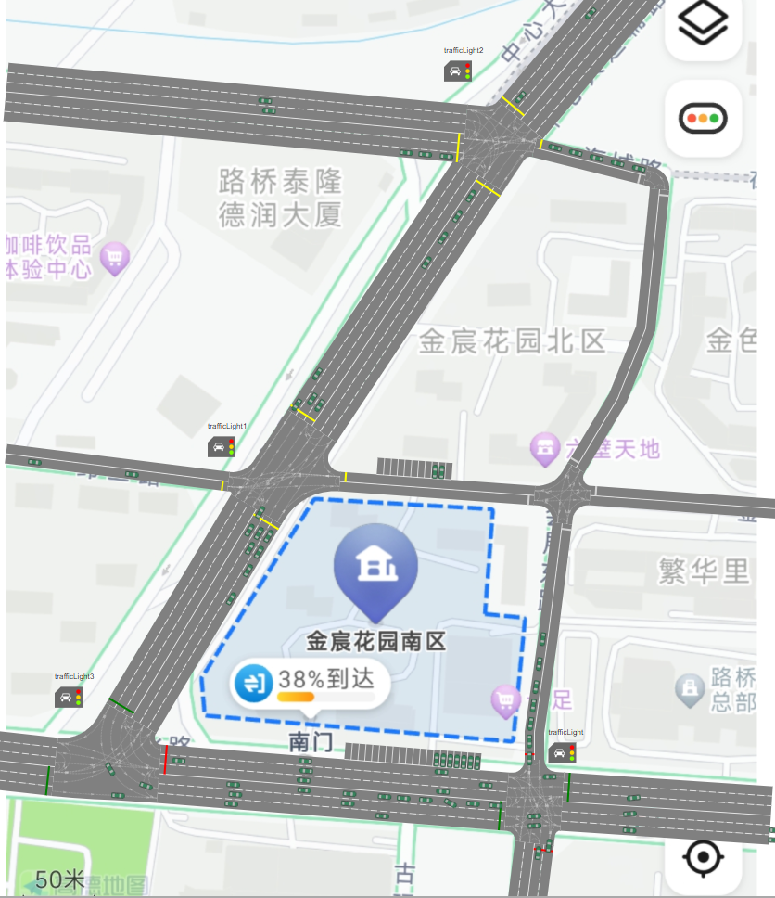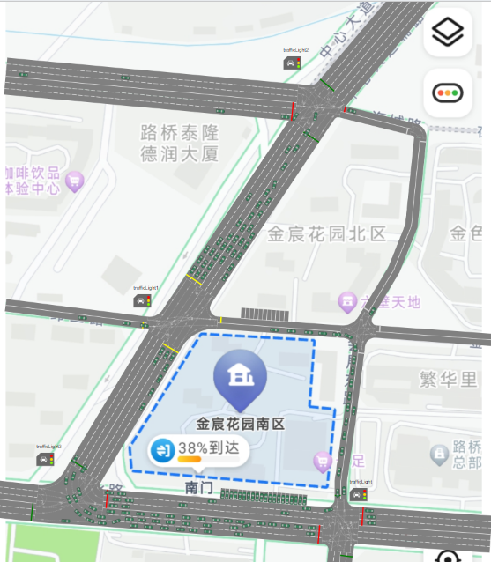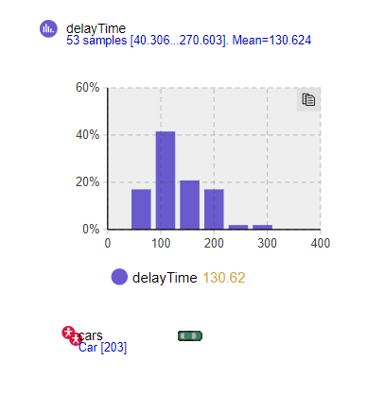 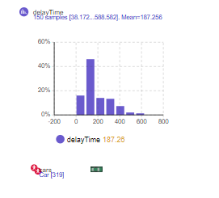

**Parameters and its function:**

**Traffic lights: Set traffic lights and related parameters**

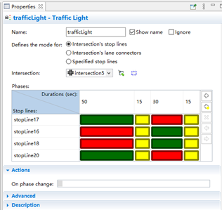

Intersection: Choose the appropriate intersection

Phases: Set traffic lights and their corresponding times

**Histogram Data: Used to collect the corresponding data**

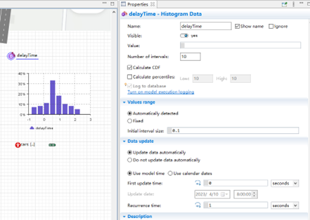

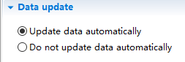

Update data automatically: To update data automatically.

**Histogram: Turn the collected information into a graph**

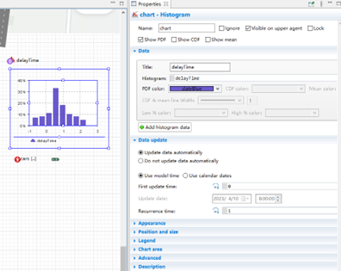

**Agent Type: A custom created object**

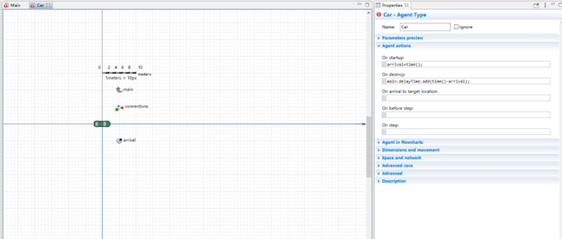

On startup: The event that is fired at the beginning

On destroy: The event that is fired at the end

**Conclusion:**

In this task, we learned how to set up traffic lights in the AnyLogic model and how long the traffic lights will last. We also learned how to create an Agent Type and introduce it into the original model. At the same time, we use Histogram Data to automatically collect and visualize information about vehicle flow.